Open OpenVpn – Select Menu:
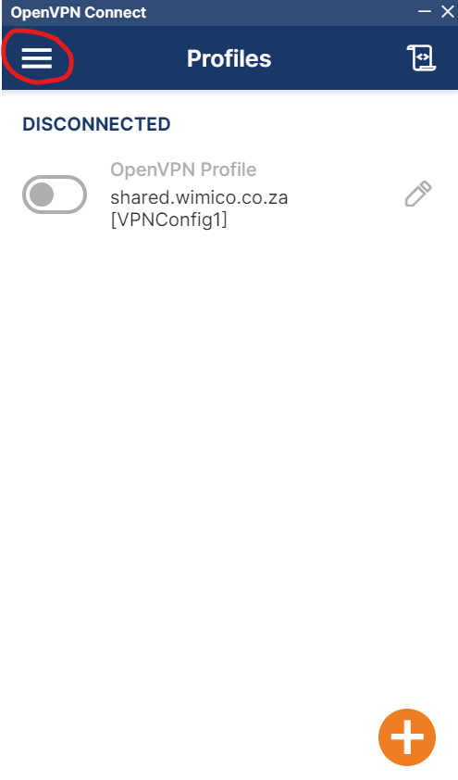
----------------------------------------------------------------------------------------------------------------
Select – Import File
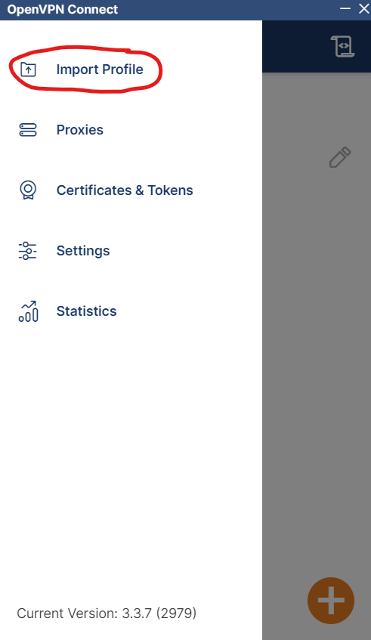

Select File:
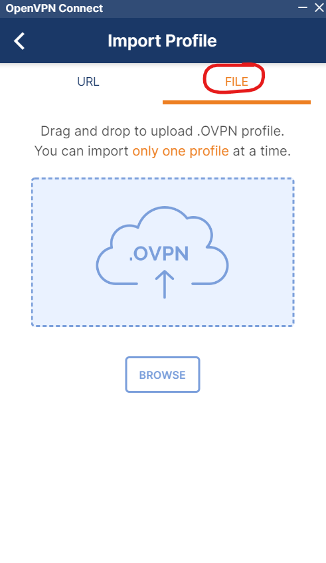
Browse to the Config File sent to you and select it, you will get the following window:
Insert the Username sent to you.
Select the Save password box and insert the password sent to you then click on Connect:
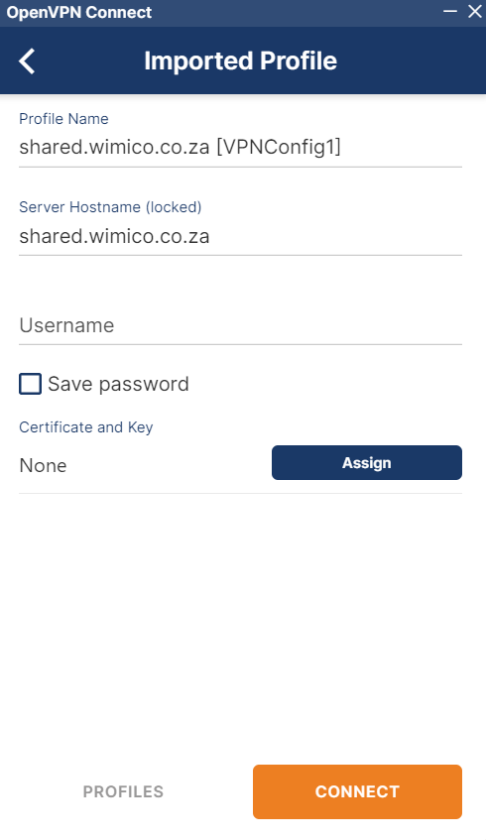
Tick the box en select Continue: “Only if this pops up”
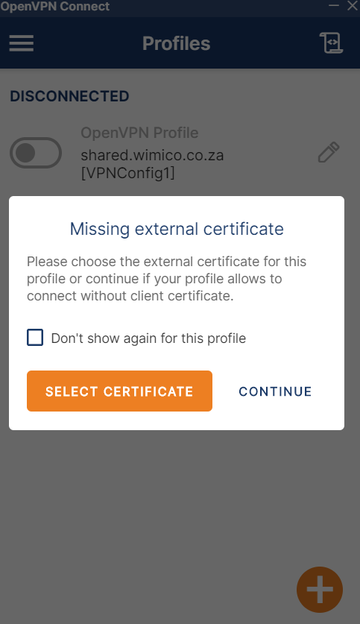

You now have 2 Openvpn profiles – the new one and the old one.
To delete the old one, switch off the current VPN connection: Toggle the Green switch to off:
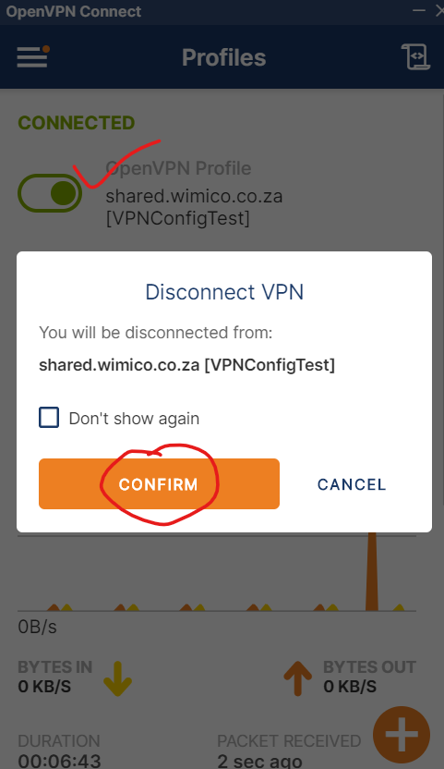
Now edit the old connection, scroll to the bottom and delete it:
